
Featherstone News
https://www.featherstonenurseryschool.co.uk MAY 2026
Dates for your diary:
Thursdays: Stay and Play (under 2s) every Thursday morning – 9:45 – 11:15am at OSBORNE NURSERY SCHOOL.
Monday 27th April – The Hatching experience – Caterpillars and duck eggs
8th, 11th,12th and 15th May – Number Walk in Explorer’s – check TAPESTRY FOR DETAILS.
Wednesday 13th May – Group photographs with Academy.
Monday 25th May – Friday 29th May – HALF TERM
Wednesday 10th June Little Learners Park Trip –
Wednesday 17th June - Explorers trip to the park in Lichfield.
WC 29th June – Parent/ carer meetings

Please remember to telephone us on 675 3408 if your child is too ill to be at nursery.

Nursery News:
Angie and her animals were fantastic! We saw a frog, a lizard, a tortoise, a chinchilla, a hedgehog and an owl. Angie talked to us about the animals and what they like eat and how they move – we even got to stoke the animals!
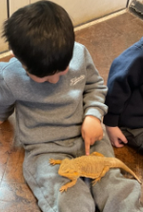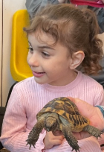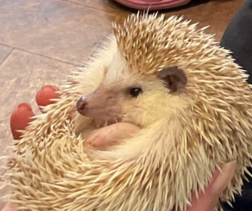

We would like to welcome of our new children to Exploeres and Little Learners – the children are gradually setting in to their new setting and making new friends – WELCOME everone! Children from Little Learners have moved up to Explorers with a new key worker. They have settled really quickly and are enjoying their new environments. Well done everyone!

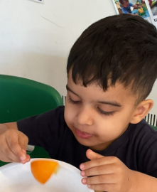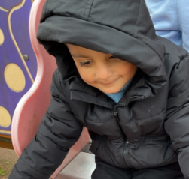

Attendance is very important at Nursery. We like to see you for all your sessions each week. We like families to aim for attendance to be between 95 and 100%. Look out for the Cool Kittens stickers
Congratulations to BUMBLE BEES AM and RABBITS AM for the best attendance in Nursery in April 2026. FANTASTIC!! Well done to the parents and carers too.

The hatching experience: We have had 5 eggs delivered and they are currently sitting in the incubator, and we are waiting for them to hatch. Little Learners have caterpillars, and they are just beginning to change into a cocoon. It is very exciting.






This year we will be working towards reaccrediting our Rights Resecting Award. You will have seen our posts about ‘ I have the right to be safe’
Terry the Tiger is helping the children understand their rights and use the language of rights. When is your turn to take Terry home?!

What do you do at home to relax and play? We would love to see some photographs of activities that you do.

INTERNET SAFETY

Teach your child to talk to you about their internet use, don’t leave your child alone on line. Ensure that you have applied parental controls and you have rules around screen time and acceptable websites and apps.

School Places: If your child is due to start school in September, you should have received the name of the school. It is an exciting time. At nursery we have already stated to talk about school and prepare the children for this change. We will be contacting the local primary schools, hosting visits and attending transition events to share information with schools. We hope that this will help your child to settle into school life quickly.

This month’s recommended reads are:



We are reading these books in nursery. The Very Hungry Caterpillar is being shared with Little Learners – they have their very own caterpillars in class! They are watching them grow and change.
‘Oh Dear’ links to our projects all about life cycles and changes. Enjoy!

As the weather gets warmer (hopefully!) don’t forget to apply sun cream before arriving at nursery. You can also send a sun hat to; this helps to protect their head from the sunshine as they play outside. Please name all items of clothing.

